4th Order Hairpin Bandpass Filter

# Youssef Samwel

# [yo800238@ucf.edu](mailto:yo800238@ucf.edu)

# EEL5437C Microwave Engineering

Prof. Dr. Xun Gong - Section 0012



# Resonator Synthesis

From microwave theory we know that a transmission line terminated with opens on both ends will be resonant at half the guided wavelength. The guided wavelength is determined from effective epsilon and trace characteristic impedance. For this filter, the desired resonance was at 3.6 GHz; given this constraint we can compute the guided wavelength of a microstrip transmission line using the following method.

The first critical step in the synthesis of the resonator is determining the copper trace width. To compute the dimensions of microstrip line I used an online calculator [https://www.pasternack.com/t-calculator-microstrip.aspx] and was able to compute a width of 1.78mm for a 50 transmission line.

Given that the substrate is a Roger’s RO4003C with a dielectric constant of 3.55 and height of 31 mil (.7874 mm); we can compute the effective dielectric constant using the following equation,

Now we can compute the ideal resonator length,

Given this information we can simulate the resonator in HFSS, the following is resonator structure,

Initial Resonator Structure

The following are the dimensions of the structure: Trace width: 1.78 mm, Probe length: 11.03 mm, Resonator length: 24.96 mm, substrate thickness: 31 mil, substrate width: 16mm, substrate length: 50mm.

The following is S21 dB plot of the resonator,

Initial S21 dB Plot

It is apparent that the resonator center frequency is not 3.6 GHz but 3.442 GHz. This is due to assumption that were made in previous computations. The previously computed resonator length did not account for edge effects. To resolve this issue, we can adjust the resonator length to reach the desired frequency. In this case to increase the center frequency, we need to shorten the resonator length.

|  |  |
| --- | --- |
| Length | Center Frequency |
| 24.96 | 3.442 |
| 24.52 | 3.6105 |
|  |  |

We now can move to the hairpin resonator structure,

Initial Hairpin Structure

I arbitrarily decided to make the gap 24% of total length and the lines

3.6 GHz, Ripple BW = 0.24 GHz, Fourth Order, Hair Pin Structure, S11 in the ripple bandwidth: < -15 dB

Friday - 11/17/2023

The following is the design Chebyshev table,

Low pass prototype



Saturday 11/18/2023

Goal: bandwidth prototype and begin filter T-line transformation.

[Resonator Tuning]

Initial Resonator Structure

The resonator was initially configured with a total length of λ/2; however, determining the optimal internal coupling to 3.6 GHz necessitated clarification of the appropriate spacing inside the resonator. To address this, I conducted a simulation sweep ranging from 0.1mm to 2mm, with increments of 0.025mm, in order to identify the desired spacing. The following is HFSS simulation of the sweep.

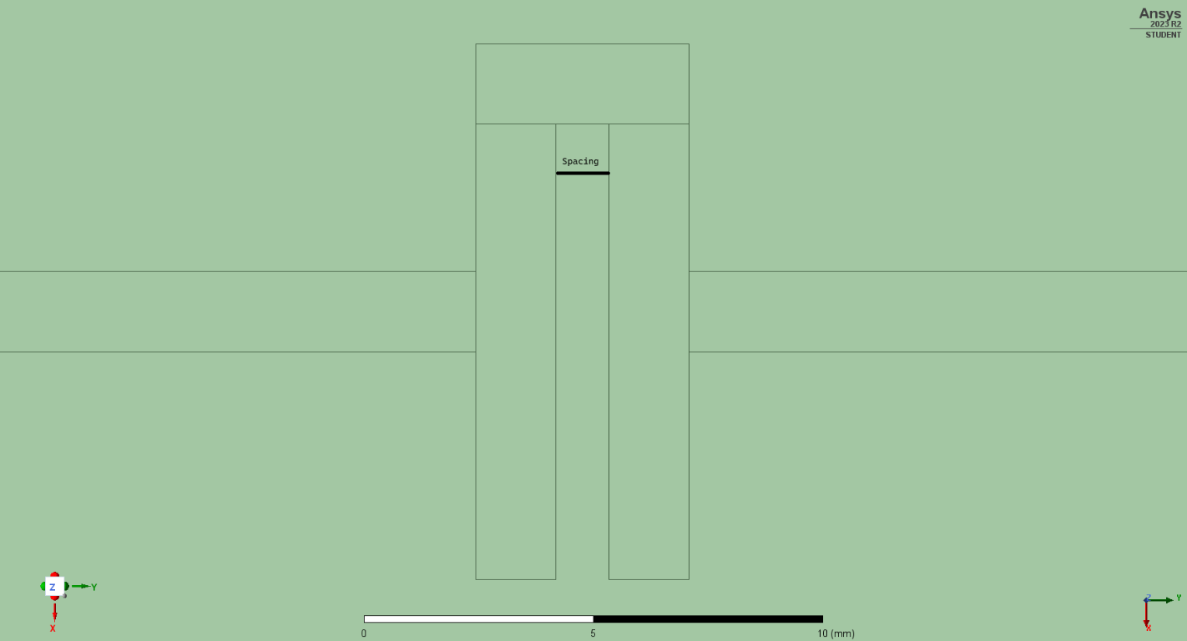To ascertain the optimal spacing length, we can construct the following design chart and interpolate the spacing values accordingly.

Simulation Sweep

|  |  |
| --- | --- |
| Spacing (mm) |  |
| 3.7480 | 3.798 |
| 4.2977 | 3.600 |
| 4.3726 | 3.573 |
| 4.9973 | 3.404 |
| 5.6219 | 3.349 |
| 6.2466 | 3.256 |
| 6.8713 | 3.207 |
| 7.4959 | 3.170 |

Running the simulation using a spacing of 4.2977 mm (0.172) yielded an plot centered at 3.6 GHz.

dB Plot

dB Plot

[Qext synthesis]

offset = 1.8mm

offset = 2.1mm

offset = 2.4mm

offset = 2.7mm

offset = 3mm

|  |  |  |  |  |  |  |  |
| --- | --- | --- | --- | --- | --- | --- | --- |
| Offset (mm) |  |  |  |  |  |  |  |
| 1.8000 | 4.007 | -7.44 | 3.92 | -97.44 | 4.091 | 82.56 | 23.43275 |
| 2.1000 | 4.018 | -8.05 | 3.912 | -98.05 | 4.122 | 81.95 | 19.13333 |
| 2.4000 | 4.028 | -6.67 | 3.907 | -96.67 | 4.149 | 83.33 | 16.64463 |
| 2.7000 | 4.012 | 0.07 | 3.871 | -89.93 | 4.15 | 90.07 | 14.37993 |
| 2.8521 | 4.023 | -3.44 | 3.876 | -93.44 | 4.172 | 86.56 | 13.59122 |
| 2.8600 | 4.018 | -0.11 | 3.868 | -90.11 | 4.166 | 89.89 | 13.48322 |
| 3.0000 | 4.023 | 0.24 | 3.863 | -89.76 | 4.182 | 90.24 | 12.61129 |

The desired are computed from Chebyshev table in the following method,

Simulation extrapolation for optimal offset,

[Coupling K simulation]

First HFSS Sweep

